Genki I & II

Table of Contents
Random phrases 5
Lesson 1 5
1. X は Y です 5
2. Question Sentences 5
3. Noun₁ の Noun₂ - Connect two nouns 5
Lesson 2 7
1. これ / それ / あれ / どれ 7
2. この / その / あの / どの + Noun 7
3. ここ / そこ / あそこ / どこ 7
4. だれの Noun – Whose 7
5. Noun も- This too 8
6. じゃないです – negate 8
7. ～ね/～よ – seek agreement / I tell you (fully confident) 8
Lesson 3 8
1. Verb Conjugation 8
2. Verb Types and “Present Tense” 9
3. Particles 9
4. Time References 9
5. ～ませんか (extend invitation) 10
6. Frequency Adverbs 10
7. Word Order 10
8. The Topic Particle は 10
Lesson 4 11
1. X があります / います (“there is/are X”) 11
2. Describing Where Things Are 11
3. Past Tense of です 12
4. Past tense of verbs 12
5. も – two or more people perform the same activity 12
6. 一時間(いちじかん) - duration of an activity 12
7. たくさん – expression of quantity 13
8. と – Connect two nouns & “together with” 13
Lesson 5 13
1. Adjectives (Present Tense) 13
2. Adjectives (Past Tense) 14
3. Adjectives (Noun Modifications) 14
4. すき(な) / きらい(な) – like/dislike 14
5. ～ましょう/～ましょうか (Let’s) 14
6. Counting 14
Lesson 6 15
1. て-form 15
2. ～てください (Polite request, please do for me) 15
3. Describing Two Activities 15
4. ～てもいいです (You may do, activity that is permitted) 16
5. ～てはいけません (You must not do) 16
6. ～から (Because) 16
7. ～ましょうか (Offering Assistance, Let me do) 16
Lesson 7 16
1. ～ている (action in progress) 18
2. ～ている (Result of change) 19
3. メアリーさんはかみがながいです (Describe somebody) 19
4. Adjective/Noun Te-forms for joining sentences 20
5. Verb Stem + にいく (purpose of movement) 20
6. Counting People 21
Lesson 8 21
1. Short forms 21
2. Short forms in informal speech 22
3. Short forms in quoted speech: ～とおもいます (describe what you think) 22
4. Short forms in quoted speech: ～といっていました (quote someone else, else’ utterances) 22
5. ～ないでください (request someone to not do something) 22
6. Verb のがすきです / じょうずです (describe what you like/dislike doing) 23
7. The Subject Particle が 23
8. なにか and なにも (something / anything) 23
Lesson 9 23
1. Past Tense Short Forms 23
2. Past Tense Short Forms in Informal Speech 24
3. Past Tense Short Forms in Quoted Speech: ～とおもいます (I think that, report what you think took place in the past) 24
4. Past Tense Short Forms in Quoted Speech: ～といっていました (heard somebody say a sentence) 24
5. Qualifying Nouns with Verbs and Adjectives 24
6. もう～ました and まだ～ていません (event that happened at a certain time) 24
7. Explanation から, situation 25
Lesson 10 25
1. Comparison between Two Items 27
2. Comparison among Three or More Items 28
3. Adjective/Noun + の (clear on what is being refereed to) 28
4. ～つもりだ (person planning to do in the future, intend to do, plan to do, intention) 28
5. Adjective + なる (to become, indicating a change) 29
6. どこかに/どこにも (expressions for some and many ~ L.8 – 8 for other set) 29
7. で (means of transportation and instruments used) 30
Lesson 11 30
1. ～たい (Hope or aspiration, Want to do) 30
2. ～たり～たりする (do event as example, not specific order) 31
3. ～ことがある (you did something, something happened in earlier times) 31
4. Nouns A や Noun B (things are proposed as examples) 31
Lesson 12 31
5- なければいけません/なきゃいけません (must/needs to) 32
1. ～んです (statement to explain things) 32
2. すぎ(たので)/ すぎる (too much, to excess) 32
3. ～ほうがいいです (it is better (for you) to do) 33
4. ～ので (give reason for situation) 33
5. ～なければいけません / ～なきゃいけません (necessary to do something, something must be done) 33
6. ～でしょうか (tentative question, not embarrassed when someone does not know the answer to a question, show politeness) 33
Lesson 13 34
1. Potential Verbs 35
2. ～し(mention more than two reasons) 35
3. ～そうです (it looks like) 35
4. ～てみる(doing something tentatively, trying something) 35
5. なら (Y only applies x, not general) 35
6. いっしゅうかんにさんかい (frequency of events over period of time) 35
Lesson 14 35
3 – あげる・くれる・もらう 36
1. ほうし (I want something) 37
2. ～かもしれません (it is a possibility) 37
3. あげる/くれる/もらう (giving) 37
4. ～たらどうですか (advice or recommendation) 37
5. Number + も/Number + しか + Negative 37
Lesson 15 37
1. Volitional Form (suggest plan to close friend) 38
2. Volitional Form + とおもっています (talk about resolution) 38
3. ～ておく (action performed in preparation of something) 38
4. Using Sentences to Qualify Nouns 38
Lesson 16 38
1. ～てあげる/てくれる/てもらう (helping verbs, giving or receiving of services) 38
2. ～ていただけませんか (Make a request, different degrees of politeness) 38
3. ～といい (Hope something nice happens) 38
4. ～時(とき): (While/When something happens / Describe when something happens or happened) 38
5. ～てすみませんでした (Describe things you have done that you want to apologize for) 38
Lesson 17 38
1: ～そうです (I hear) – I have heard that this thing is…. 38
2: ～って – quote what you have heard 38
3: ～たら - B is valid only if A is fulfilled 38
4: ～なくてもいいです – do not need to do 38
5: ~みたいです – resembles someone / looks like someone / acts like / it seems that 39
6: ～前（まえ）に／～てから – event before something happens 39
Lesson 18 39
1 - Transitivity Pairs 39
2 ～てしまう 39
3 ～と 39
4 ～ながら 39
5 ～ばよかったです 40
Lesson 19 40
1 Honorific Verbs / Graciously 41
2 Giving Respectful Advice 41
3 ～てくれてありがとう 42
4 ～てよかったです 42
5～はずです 42
Lesson 20 43
1. extra modest expressions 43
2. humble expressions 44
する compound verbs, only have ご or お 45
3. without doing X 46
4. questions within larger sentences 47
5. the name of objects. 48
6. easy/hard to do 49
Lesson 21 50
1. Passive sentences / inconvenienced by something / bothered by 50
2. てある - situation that has been brought about on purpose (person remains unnamed) 53
3. ~間に ->（あいだ）に ~ event takes place in middle of another event 53
4. adjective + する: “to make” 55
5. ～てほしい: “I want him to do...” 56
Lesson 22 57
1. Causative sentences 57
2. verb stem+なさい(command) 59
3. ~ば conditional (if A, then B) 59
4. ～のにdespite 60
5. ～のような／～のように(is like / do something like...) 61
Lesson 23 62
1. Causative passive sentences (made to do, harassed, talked into doing something you don’t want to do) 62
2. Even if.. with ても 63
3. Decide to do…with ～ことにする 64
4. Until…with ～まで 65
5. Methods with 方（かた） 65
Misc. 65
Days of the week: 65
Months: 65
End of sentence: 66
Useful phrases: 66
Particles: 66

Other:
ee – sound for past tense verbs

Random phrases
なので – since
みたいです – it seems that
わあ - “wow”

Lesson 1

X は Y です
は = topic particle (read as wa),
example:
X は Y です = X (the topic) is Y.

Question Sentences
To ask question, です => ですか? (add ka).
なんですか is used to ask *what* is something
example:
X ですか? = is it X? (yes/no qn)
X は なん ですか? (what is X?)

Noun₁ の Noun₂ - Connect two nouns

の particle: it just means 的 in chinese.
example:
日本語の学生 = 日本语的学生 in chinese.

Useful Expressions:
Time
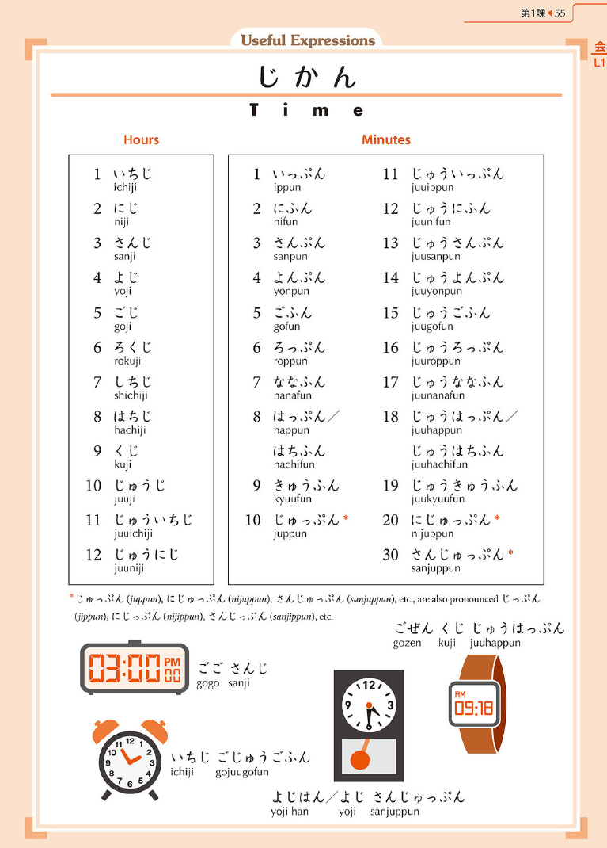

Lesson 2

これ / それ / あれ / どれ

これ -> This one [near me] (n.)
それ -> That one [near you] (n.)
あれ -> That one [over there] (n.)
どれ(が) -> Which one [interrogative, unspecified] (n.)

これ/この/ここ (starts with こ) = this (unspecific) / this (specific noun)/ this (place), near to you.

それ/その/そこ = that (unspecific)/that (specific noun)/ that (place), near to the other person u are talking to.

あれ/あの/あそこ = that (unspecific)/that (specific noun)/that (place), far away from both you and the person u are talking to.

examples (literal translation):
これ は いくら ですか?
This thing (near me), how much is it?

その 時計 は 三千円 です。
That watch (near you) is 3 thousand yen.

きっさてん は あそこ です。
The cafe is over there (far from both of us).

この / その / あの / どの + Noun

この -> This (adj.)
その -> That (adj.)
あの -> That [over there] (adj.)
どの(が) -> Which (adj.)

ここ / そこ / あそこ / どこ

ここ -> Here
そこ -> There [near you]
あそこ -> There [away from us]
どこ(が) -> Where

だれの Noun – Whose

だれ ・ だれの (が)
Who Whose (adj.)
どれ/どの/どこ = which (unspecific)/which (specific noun)/which (place)

*use with が particle instead of は

example:
どれ が あなたの ペンですか?
which one is your pen?

だれ= who?
だれの= whose? (谁的 in chinese)

example:
これは だれの かばんですか?
Whose bag is this?

Noun も- This too
も replaces は, is used to compare similarities.

example:
X は Z です。(X is Z.)
Y も Z です。(Y is *also* Z)

じゃないです – negate
X は Y です。(X is Y)
X は Y じゃないです。(X is not Y)

*side note: instead of じゃない (more colloquial), can also use じゃ ありません (no です at the end) or でわ ありません (same no です at the end), in increasing "formal-ness".

～ね/～よ – seek agreement / I tell you (fully confident)
ね added at the end of sentence to say (... right?/ ... is it?)

example:
これ は 肉 じゃない ですね。
(This isn't meat, right?)

よ added at the end of sentence to clarify/assure things.

example:
とんかつ は 魚 じゃないですよ。=
tonkatsu isn't fish

*(spoken like, let me tell you/to clarify, tonkatsu isn't fish)

Lesson 3

Verb Conjugation
There are 2 types of verbs, ru verbs and u verbs, they are conjugated differently.

Ru verbs: eg. 食べる
present tense: 食べ ~る~ => 食べます (change ru to masu)
present negative: 食べ ~る~=> 食べません

U verbs: eg: 飲む
present tense: 飲む => 飲みます
present negative: 飲みません

(convert the u to i vowel, eg, mu => mi, then add masu or masen)

Irregular verbs:
する => します/しません
くる => きます/きません

*to identify ru/u verbs, firstly, if the verb doesnt have る, its a u verb.

next, if there is a u o vowels before ru, is u verb,
if theres i e before る, most cases is ru verb (exception: 帰る is u verb)

Or!!! just memorise accordingly.

Verb Types and “Present Tense”
Present tense either means that
1. u are saying u often do something *(habitual actions)* or
2. when describing u are going to do something in the *future*.

Particles
を (pronounced as "o"): describes direct objects, what you do to the noun.

eg: コーヒーを飲みます
(i drink coffee)

で: place where the event happens.

eg: 図書館でほんを読みます
(I will read books in the library)

に:
1. goal of movement (towards)
2. time (use に right after the time words)

eg:
1. 私はうち に 帰ります (i will return home)
2. 十一時 に 寝ます (I will sleep at eleven)

*approximate time references can be made by replacing に with ごろ.
eg: 十一時 ごろ 寝ます (i will sleep at around 11)

へ (pronounced "e"): indicates goal of movement (can be used to replace に in the goal of movement sense).
eg: 私はうち へ 帰ります。

Time References
- Use に when referring to days of the week (sunday), or numerical time expressions like 10:45 and "in september"
- Dont use に when u have a reference to today (eg, today, tomorrow, next week) or regular intervals like (everyday), or asking about "when?".

day of the week + に
time + に

No に needed for:
- present moment expressions: today, tomorrow
- regular intervals: every day
- asking “when”
Not needed for the following but can be used to add emphases, personal preference:
- parts of day: in the morning, at night
- the weekend

～ませんか (extend invitation)
しませんか..
use ませんか as in invitation: (its like wont 'cha)
昼ご飯 を 食べませんか?
("wont 'cha" eat lunch with me?)

Frequency Adverbs
私は 時々 喫茶店 に 行きます
(I sometimes go to a coffee shop)

However: to describe infrequent activities (全然, あまり), u must always use the negative form of verbs at the end of the sentence (which is ません)

eg: たけしさん は あまり 勉強しません。(takeshi does not study much)

*extra side notes:
行く= movement in a direction away from speaker.
来る = movement towards the place the speaker is.

Word Order
General word order (sentence structure):
- topic time place object verb
- topic frequency time goal verb

私は今日図書館で日本語を勉強します。
Topic – time – place – object – verb
I will study Japanese in the library today.

私はよく七時ごろうちへ帰ります。
Topic – frequency – time – goal – verb
I often go back home at around seven.

The Topic Particle は
Topic of one’s utterance:
(“As for item X, it is such that…”)
メ ア リ ー さ ん はニ年生て す。 (Mary is a sophomore)
...Mary is topic of sentence

私の専攻は日本語です。 (My major is the Japanese language)
...My Major is topic of sentence

Topic phrase:
- は can be timed expression as topic of a sentence
- は used to direct listener’s attention
- invite comment/completion of sentence

Lesson 4

X があります / います (“there is/are X”)
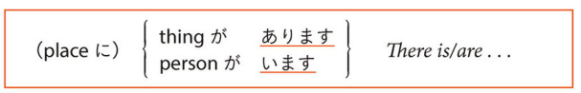
- ある/あります (う verb) - for non living things
- いる/います (る verb) - for living things
- Thing you are presenting uses が
- Place where the thing is accompanied uses に
- います and あります are descriptions of existence and location

Sentence structure:
- place → thing
- (pointing word) に (thing) が あります。
- (pointing word) に (person/living thing) が います。

NOTE: ある uses ないです instead of expected あらないです

あそこにマクドナルドがあります。
There is a McDonald's over there.

Have or own something: あります
テレビがありません。
I don't have a TV.

NOTE:
テレビがありません – I don’t have a TV.
テレビじゃありません – It isn’t a TV.
~Can use じゃ/じゃない

時間がありますか。
Do you have time?

An event will take place: あります
- Place description followed by で
あした京都でお祭りがあります。
There will be a festival in Kyoto tomorrow.

火曜日にテストがあります。
There will be an exam on Tuesday.

あしたは日本語のクラスがありません。
There will be no Japanese class tomorrow.

Living things: います
あそこに留学生がいます。
There’s an international student over there.

- Say you have siblings and friends
日本人の友だちがいます。
I have a Japanese friend.

Describing Where Things Are
General form:
X は Y の _____ です。

where ____ is a location word, eg, left/right.

location words: 右, 左, 上, 下, 前, 後, 中, 近く, 隣.
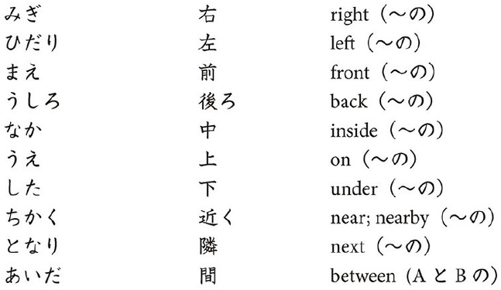
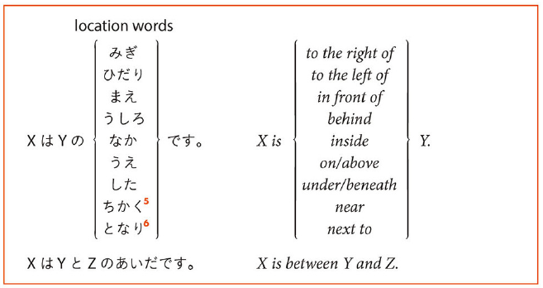
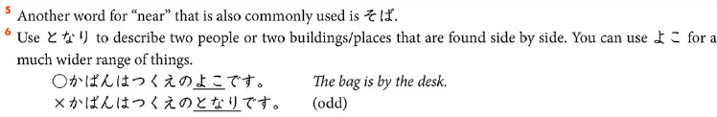
For 間 (between), use: X は Y と Z の 間です (X is between Y and Z)

*Extension: Since this describes a place, and events can happen at places (chap 3 verbs and places), we can use で particle to do the same thing as chap 3.

Example:
私はモスバーガーの前 で メアリーさんを待ちました。
I waited for Mary in front of the mos burger place.

Past Tense of です
for です:
past tense: でした
past negative: じゃなかったです

for ます (verbs):
past tense: ました
past negative: ませんでした

*tip: if got た = past tense.

Past tense of verbs

も – two or more people perform the same activity
も means also.
- Replaces は, が, and を particles
- Particles に and で followed by も
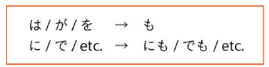
example:
私は先週京都 に 行きました。
大阪 にも いきました。
I went to Kyoto last week.
I also went to Osaka.

一時間(いちじかん) - duration of an activity
add 一時間 or any other duration noun before the verb.

example:
メアリーさん は そこで たけしさん を *一時間* まちました。
Mary waited for Takeshi there for one hour.

*add くらい to the duration (一時間くらい) for approximate timing, and add 半 to indicate half an hour/minute etc)

たくさん – expression of quantity
add 一時間 or any other duration noun before the verb.

Sentence structure: … は(or other particle) - Duration – verb – verb conjugation.

example:
メアリーさん は そこ で たけしさん を *一時間* まちました。
Mary waited for Takeshi there for one hour.

*add ぐらい to the duration (一時間ぐらい) for approximate timing, and add 半 to indicate half an hour/minute etc)

と – Connect two nouns & “together with”

1. To connect two things in one sentence (and)
example:
日本語 と 英語 を 話します。
I speak Japanese and English.

2. Means "together with"
Sentence structure:
PersonA は PersonB と...
example:
メアリーさん は スーさん と 韓国 に いきます。
Mary will go to Korea with Sue.

Note that it isn’t Mary と sue because Mary is the topic of the conversation, and she is the one that's going with Sue.

Lesson 5
～まで – to (a place), as far as (a place), till (a time) (wrong chapter or incorrect grammar?)

Adjectives (Present Tense)
There's two types of adjectives, な adj and い adj, which is based on the last syllable when they modify nouns.

い adj: 怖い先生
山下先生は 怖い先生 です。
Yamashita is a scary teacher.

な adj: 元気な先生
山下先生は 元気な先生 です。
Yamashita is an energetic teacher.

Conjugation of い adjectives:
寒いです > 寒くないです (negative)
寒いです > 寒かったです (past)
寒くないです > 寒くなかったです (past negative)

Note for past negative: change nai to nakatta, nai is also an i adjective
Another note: いい becomes よい, then conjugate from there.

Conjugation of な adj:
元気です。is the original form, just conjugate like how u conjugate desu as learnt from chap 4 (じゃない じゃなかった でした)

To say stuff like "a little hot" "very hot", put ちょっと and とても respectively in front of the adj.

example:
この部屋は ちょっと暑い です。
This room is a little hot.

Adjectives (Past Tense)

Adjectives (Noun Modifications)
-い and な adjectives can be used to modify nouns
-put dictionary form of い before noun to modify
-な is still present for な adjectives (was omitted before)
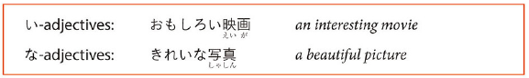

すき(な) / きらい(な) – like/dislike
To say u like or dislike something:
X は Y が 好き/嫌い です。

example:
山下先生は魚が嫌いです。
Yamashita dislikes fish.

use 大好き/大嫌い instead of とても 好き/嫌い

to say u neither like or dislike something:
好きでも 嫌いでも ないです。

using them as adjectives:
これは 私の 好きな本 です。
(This is my favorite book)

～ましょう/～ましょうか (Let’s)
ます > ましょう / ましょうか
ましょう = "Let's ..."
ましょうか = "Why dont we .../ Shall we"

example:
一緒に図書館で勉強しましょう。
Let's study in the library together.

喫茶店でコ－ヒーを飲みましょうか。
Shall we drink coffee at a coffee shop?

Counting
リーさんはTシャツを三枚買いました。
Lee bought three T-shirts.

Lesson 6

て-form
There is something called te form which is used extensively for many things. (explained later)

Heres how to conjugate:

Ru verbs: (る => て)
食べる => 食べて

For u verbs:

ends in う つ る: (って)
会う => 会って
待つ => 待って
撮る => 撮って

ends in む ぶ ぬ: (んで)
読む => 読んで
遊ぶ => 遊んで
死ぬ => 死んで

ends in く ぐ: (いて/いで)
書く => 書いて
泳ぐ => 泳いで
*note: for 行く=> 行って

ends in す: (して)
話す => 話して

irregular verbs:
する => して
くる => きて

～てください (Polite request, please do for me)
Use てください。

example:
教科書 を 読んでください。
(please read the textbook)

Describing Two Activities
- Use て-form if u want to connect two or more verbs together,
- と is to connect nouns
- て is for verbs.

i) to show sequence of events

example:
今日は、六時に起きて、勉強しました。
(today i woke up at six, and studied.)

ii) relates the verb to the rest of the sentence.

examples:
バスに乗って、会社に行きます。
(i take a bus to work)

教科書を忘れて、すみません。
(i forgot my textbook, sorry)

～てもいいです (You may do, activity that is permitted)
use てもいい to say "u may do..."
to ask permission, say てもいいですか

example:
教科書 を 見てもいいですか
(may i see the textbook?)

はい 、 見てもいいですよ。
(yes u may)

～てはいけません (You must not do)
Use てはいけません (は pronounced as wa) to show that u cannot do something in a strong tone.

example:
ここで 写真 を 撮ってはいけません。
(u must not take pictures here)

～から (Because)
add から to the end of the sentence to explain the reason for something.

General form:
(situation)。(explanation)から。

example:
私は今晩は勉強します。明日テストがありますから。
I will study tonight. That's because there is a test tomorrow.

Or
explanation before situation:
明日テストがありますから, 私は今晩は勉強します。

*note: 遅い is adj, 遅く is adverb. same for 早い/早く etc.

～ましょうか (Offering Assistance, Let me do)
- Offering assistance: “Let me do...”
- ...ます -> ...ましょうか

Lesson 7
Vocab:

Kana | Kanji | English
あね | 姉 | (my) older sister
アパート |  | apartment
いもうと | 妹 | younger sister
うた | 歌 | song
おとうと | 弟 | younger brother
おとこのひと | 男の人 | man
おにいさん | お兄さん | older brother
おねえさん | お姉さん | older sister
おんなのひと | 女の人 | woman
かいしゃ | 会社 | company
かぞく | 家族 | family
かみ | 髪 | hair
きょうだい | 兄弟 | brothers and sisters
くに | 国 | country; place of origin
くるま | 車 | car
コンビニ |  | convenience store
しょくどう | 食堂 | cafeteria; dining commons
ちち | 父 | (my) father
Tシャツ |  | T-shirt
め | 目 | eye
めがね | 眼鏡 | glasses
あたまがいい | 頭がいい | bright; smart; clever
かっこいい |  | great-looking
かわいい |  | cute
せがたかい | 背が高い | tall
せがひくい | 背が低い | short (stature)
ながい | 長い | long
はやい | 早い | fast
みじかい | 短い | short (length)
しんせつ | 親切 | kind
べんり | 便利 | convenient
うたう | 歌う | to sing
かぶる |  | to put on (a hat)
しる | 知る | to get to know
しっています | 知っています | I know
しりません | 知りません | I do not know
すむ | 住む | to live
はく |  | to put on (items below your waist)
ふとる | 太る | to gain weight
ふとっています | 太っています | to be on the heavy side
めがねをかける |  | to put on glasses
きる | 着る | to put on (clothes above your waist)
やせる |  | to lose weight
やせています |  | to be thin
けっこんする | 結婚する | to get married
が |  | but
ひとり | 一人 | one person
ふたり | 二人 | two people
もちろん |  | of course
よかったら |  | if you like

～ている (action in progress)
- conjugates like a る-verb
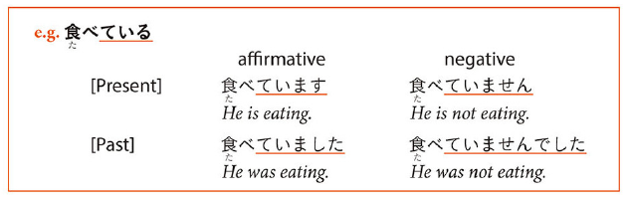
verb stem + にいく
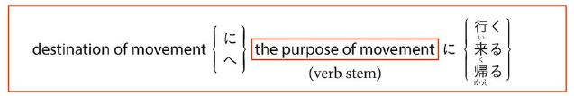
Stems:
a) Use ている to describe continuous state

example:
スーさん は 今勉強しています
(sue is studying right now)

also can use ています to describe what someone does by occupation/habit

examples:
私 は 英語 を 教えています。
I am an English teacher/i am teaching English.

メアリーさん は 毎日 日本語 を 勉強しています。
Mary studies Japanese everyday.

conjugation: (conjugate the ます)
食べています (present)
食べていません (negative)
食べていました (past)
食べていませんでした (past negative)

～ている (Result of change)
Used to describe current status/state

example:
山下先生 は 結婚しています。
Yamashita sensei is married.

トムさん は ちょと 太っています。
Tom is a little overweight.

*side note: 行く and 来る belongs to group b, thus 中国に行っています = somebody has gone to china. instead of: somebody is going to china.

メアリーさんはかみがながいです (Describe somebody)
X は(part)が(adjective).

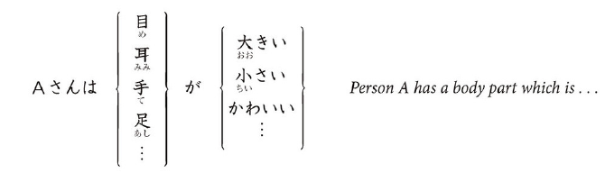

Idiom:
example:
スーさんは髪が長い。
Sue's hair is long.

Adjective/Noun Te-forms for joining sentences
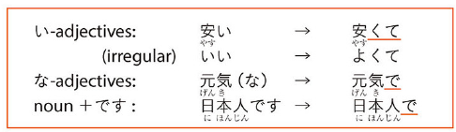

i adj:
Final い → くて
優しい => 優しくて
irregular: いい => よくて

na adj & nouns:
Add で
元気 => 元気で
日本人 => 日本人で

Sentence structure:
...て-form, Adjective/Noun (tense here determines sentence tense.)

They are used to connect sentences.
Last adjective determines the overall sentence tense.

example:
あの店 の 食べ物 は 安くて、おいしいです。
That stores food is inexpensive, and delicious.

山下先生 は 日本人で、五十歳ぐらいです。
Yamashita sensei is a Japanese person, and he is about fifty years old.

Verb Stem + にいく (purpose of movement)
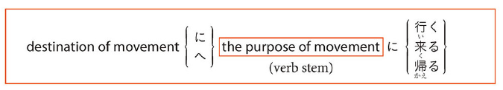

general form:
(destination) に/へ (purpose) に 行く/来る/帰る。

example:
デパート に かばんを買い に 行きました。
I went to the department store to buy a bag.

Counting People
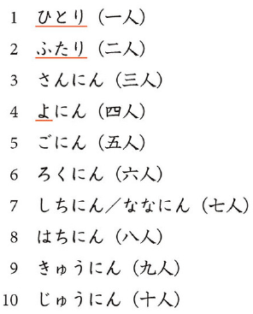

Count people in a class:
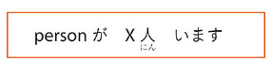

Lesson 8

Short forms
Short forms are used for many things discussed later (eg quotes, thoughts, informal speech).

Lets first learn the conjugations:

Present tense:

verbs: 読み ます => 読む

i adj: 可愛い です => 可愛い

na adj/noun:
元気 です => 元気だ
学生 です => 学生だ

Present tense negative:

verbs1: 読む => 読まない

i adj: 可愛いくない です => 可愛いくない

na adj/noun:
元気じゃない です => 元気じゃない
学生じゃない です => 学生じゃない

*tip: short form, just cut out the masu/desu politeness

1now for verbs, short form negative conjugations:

ru verbs (る => ない):
食べる => 食べない

u verbs (change u ending to anai):
書く => 書かない
死ぬ => 死なない
読む => 読まない
買う => 買わない (note that う => わ)

irregular verbs/exception:
する => しない
くる => こない
ある => ない

Short forms in informal speech
basically means can use short forms and dont need to be so polite etc

Short forms in quoted speech: ～とおもいます (describe what you think)
Use short form + と思います / と言っていました to express thoughts/ quote speech.

examples:
スーさんは、明日試験 が ある と言っていました。
(sue said that there would be an exam tomorrow)

(私は) たけしさん は メアリーさん が 好きだ と思います。
(i think takeshi likes mary)

*extension: if u wanna say she thinks that he is cool (2nd/3rd person thoughts) use と思っています (like the above she said... uses と言っていました)

example:
彼女 は 彼 が かっこいい と思っています。
(she thinks he is cool)

Short forms in quoted speech: ～といっていました (quote someone else, else’ utterances)
“They said”
short form + と言っていました

～ないでください (request someone to not do something)
use negative short form + でください。

example:
ここで 写真 を 撮らない でください
(please dont take pictures here)

Verb のがすきです / じょうずです (describe what you like/dislike doing)

The Subject Particle が
が is used to "fill in the blank", for example when somebody is asking who did this?

use が when asking qns about who/which/what (specific) X did something.

then say X が something.

his identity is a new piece of info provided.

example:
どのクラス が 面白いですか?
(which class is interesting?)

日本語のクラス が 面白いです。
(japanese class is.)

なにか and なにも (something / anything)
何か = something (positive)
何か = anything (question)
何も + negative = nothing at all (negative)

used on their own, without particles after it.

examples:
猫が何か持って来ました。
(the cat has brought something)

猫は何か食べましたか?
(did the cat eat anything?)

いいえ、猫は何も食べませんでした。
(no, the cat did not eat anything)

持っていく – to take something from position to another location
持って来る – to take from somewhere else to position

Lesson 9

Past Tense Short Forms
To conjugate:

past tense:
verb: 読む => 読んだ
i adj: 可愛かったです => 可愛かった
na adj & noun:
静か => 静か だった
学生 => 学生 だった

past negative:
verb: 読む => 読まなかった
i adj: 可愛い => 可愛くなかった
na adj/noun:
静か => 静かじゃなかった
学生 => 学生じゃなかった

irregular:
行く => 行った 行かなかった
いい => よかった よくなかた

Past Tense Short Forms in Informal Speech
Drop か from end of questions.
Don’t drop: かった/ だった

Past Tense Short Forms in Quoted Speech: ～とおもいます (I think that, report what you think took place in the past)
Phrase: Noun+がない – Noun is gone..

Past Tense Short Forms in Quoted Speech: ～といっていました (heard somebody say a sentence)
Short form + いっていました。

Qualifying Nouns with Verbs and Adjectives
食べる人
(the person who is eating)
(lit. the eating person)
and so on, verbs can be put before nouns to modify them and describe them.

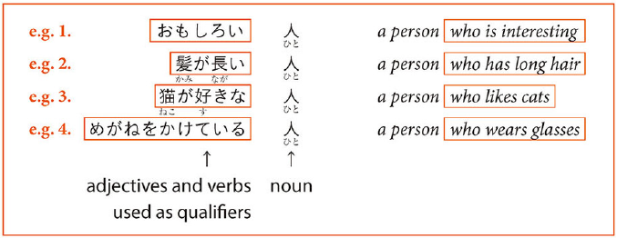
example:
あそこ で 本を読んでいる学生 は みちこさん です
The student who is reading a book over there is Michiko.

もう～ました and まだ～ていません (event that happened at a certain time)
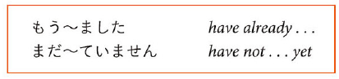
we need perfect tenses to show that we have/have not done something already.

use もう to show that u have already done something.

for example:
私は昨日ドアを閉めました
(i closed the door yesterday)

vs

私は もう 昨日ドアを閉めました。
(i have already closed the door yesterday.)

sentence 1 says nothing about the present state of the door, while sentence 2 says that even now, the door is still locked.

use まだ... ていません to show that u have not yet done something.

Sentence structure:
もう...ました。

Negative sentence:
まだ...ていません。

example:
私 は まだ 宿題 を していません
(i have not done my homework yet)

Explanation から, situation
previously, we learnt (situation), (explanation) から。
over here, から = because.

now we learn that we can also use (explanation) から、(situation).
over here, から = therefore.

example:
明日試験がある から、私は今晩勉強します。
(tomorrow there is a test, therefore i will study today)
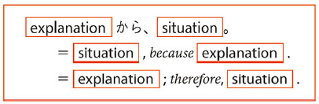

Lesson 10
あき | 秋 | fall
えき | 駅 | station
おかねもち | お金持ち | rich person
かお | 顔 | face
きせつ | 季節 | season
クレジットカード |  | credit card
ことし | 今年 | this year
サッカー |  | soccer
シャツ |  | shirt
せいかつ | 生活 | life; living
せかい | 世界 | world
ちかてつ | 地下鉄 | subway
てぶくろ | 手袋 | gloves
とこや | 床屋 | barber's
はる | 春 | spring
パンツ |  | pants
びよういん | 美容院 | beauty parlor
びん | 便 | flight
ふね | 船 | ship; boat
やきゅう | 野球 | baseball
ゆうめいじん | 有名人 | celebrity
よやく | 予約 | reservation
らいがっき | 来学期 | next semester
りんご |  | apple
あたたかい | 暖かい | warm
おそい | 遅い | slow; late
すずしい | 涼しい | cool (weather)
つめたい | 冷たい | cold (thing/people)
ねむい | 眠い | sleepy
かんたん | 簡単 | easy; simple
かかる |  | to take (amount of time / money)
とまる | 泊まる | to stay (at a hotel, etc.)
なる |  | to become
はらう | 払う | to pay
きめる | 決める | to decide
れんしゅうする | 練習する | to practice
あるいて | 歩いて | on foot
いちばん | 一番 | best
このごろ |  | these days
どうやって |  | how; by what means
どちら |  | which
どのぐらい |  | how much; how long
はやく | 早く | (do something) early; fast
～ご | 後 | in...time; after
～か～ |  | or

Comparison between Two Items
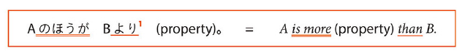
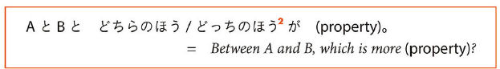
Not often used：
どちら・どっち

Sentences：
中国のほうが日本よりおおきいです。
China is larger than Japan.

日本とカナダとどちらのほうが寒いですか。
Which is colder, Japan or Canada?

カナダのほうが寒いです。
Canada is colder.

Comparison among Three or More Items
use:
(group) の中で A が 一番 (adjective)
(amongst the whole group of items, A is the most (adjective))

example:
ロシア と フランス と 日本 の中で、どこ が 一番 寒いですか?
(between russia france and japan, which has the coldest climate)

ロシア が 一番 寒いと思います。
(i think russia has the coldest climate)

季節 の中で いつか 一番 好きですか?
(which season do u like the most?)

秋が 一番 好きです。
(i like fall the most)

Adjective/Noun + の (clear on what is being refereed to)
avoid repetition, refers to person mentioned previously
use の at the end of the sentence and avoid repetition of nouns.

example:
私は黒いセーターを持っています。赤いのも持っています。
(i have a black sweater, i have a red one too)

～つもりだ (person planning to do in the future, intend to do, plan to do, intention)
(verb short form) + つもり = i intend to do (verb)

u can also conjugate the verbs and つもりです for your tenses accordingly.

example:
週末 に たけしさん と テニス を する つもりです。
I intend to play tennis with Takeshi this weekend.

山下先生 は 明日大学 に 来ない つもりです。
Yamashita sensei intends to not go to university tomorrow.

Adjective + なる (to become, indicating a change)
なる => to become
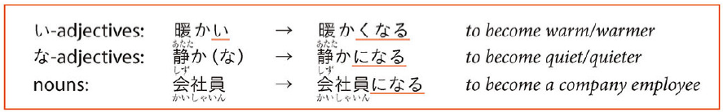
to conjugate:

i adj: 可愛い => 可愛いくなる

na adj/noun:
元気 => 元気になる
風 => 風になる

example:
日本語の勉強 が 好きになりました
I have grown fond of studying the Japanese language.

どこかに/どこにも (expressions for some and many ~ L.8 – 8 for other set)

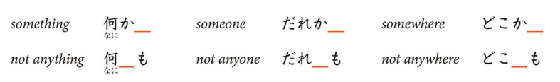
List of terms:
誰か__ = someone
誰__も = not... anyone
どこか__ = somewhere
どこ__も = not... anywhere

The particles (へ に で...) appear in the lines.
NOTE: Xも must always be followed by negative.

examples:
どこかへ行きましたか。
Did u go anywhere?

いいえ、どこへも 行きませんでした。
No I did not go anywhere.

誰か に 会いましたか?
(did u see anybody?)
いいえ、誰にも 会いませんでした。
(no, i did not meet anybody)

で (means of transportation and instruments used)
で + noun = (by the means of/ using)

example:
はし で ご飯を食べます。
I ate lunch using chopsticks.

日本 で 話しましょう
Lets talk in Japanese.

バス で 駅まで行きました
I went to the station by bus.

Lesson 11

～たい (Hope or aspiration, Want to do)
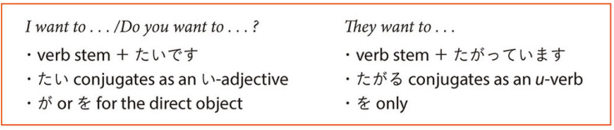
Format:
Verb stem: verb form before ます
verb stem + たいです/たくない

example:
今度の週末は、映画 (を/が) 見たいです。
This weekend, i want to see a movie.

いつか中国に行きたいです。
I want to go to china someday.

- Verb that uses をuses を or が when たい is used
- Other particles do not change
-たい conjugates as an い adj

“have wanted to” - たいと思っています
You have the thought of wanting to do something for awhile now.

- Don’t use たいです for wishes held by others
- Other people’s wishes are set as quotations, observations or guesses

Quote someone else’s wishes - と言っていました

example:
メアリーさん は チベット に 行きたい と言っていました
Mary said she wants to go to Tibet.

Observation that someone whats to do something - たがっている。
-comes from the grammar point たがる (expanded in Lesson 14)

example:
メアリーさん は 着物 を 着たがっています。
It seems that Mary wants to wear a kimono.

～たり～たりする (do event as example, not specific order)
たり, たりする: make a list, not only things intend to do

use A たり B たりする to show examples of activities A and B that u did.

This differs from using te form as te form means that u follow a sequence and the list is exhaustive, whereas for たり theres no set order and the list u provide is non exhaustive.

example:
大阪 で 買い物を したり、 晩ご飯 を 食べたります。
(in osaka, i will do things such as shopping, and eating dinner)

*extension: u can chain たり just like how u can chain も、て、と to list out more than 2 examples of what u did.
A たり B たり C たりする。

to get the たり form, just add り to the past tense form of the predicate. eg する => したり

～ことがある (you did something, something happened in earlier times)
experience of, something happened, earlier time, I have ‘never’ done that

use (verb short form past tense) + ことがある = have the experience of.

example:
富士山 に 登った ことがあります。
(i have had the experience of climbing mount fuji)

たけしさん は 授業 を 休んだ ことがありません。
(Takeshi has never been absent from classes)

Nouns A や Noun B (things are proposed as examples)
A や B = A and B, for example.

example:
京都 や 奈良 に行きました。
(i went to kyoto and nara (for example, and may have visited other places as well) )

Lesson 12
～んです – to explain
Must
-ないほうがいいですよ
~ので:
なので – since
な at the end of な adjective before ので so なので

5- なければいけません/なきゃいけません (must/needs to)

～んです (statement to explain things)
use んで to show an explanatory tone, instead of a reporting tone. Gives more context.

example:
明日 テスト が あります。(i have a test tomorrow)

vs

明日 テスト が あるんです。(i have a test tomorrow (...so i cant go out tonight) )

the second sentence gives an explanation for why u cant go out tonight, it gives context as opposed to the first sentence which just states u have a test tomorrow.

general form:
(short form) + んです。

んです does not usually appear in past or negative forms.

when it follows a noun or na adj, add な before んです。

eg:
静かなんです
学生なんです

んですか invites further clarification from the person u are talking to.

example:
どうしたんですか?
(what happened? (...u look sad pls explain))
猫が死んだんです。
(my cat died (...thats why i look so sad) )

のです is the same as んです just that it appears more in writing.

すぎ(たので)/ すぎる (too much, to excess)
(verb stem) + すぎる = "too much".
すぎる conjugates as a ru verb.

example:
早く起きすぎました
(i got up too early)
食べすぎてはいけません
(you must not eat too much)

for i and na adj, drop the i and na, then add すぎる。

examples:
この本 は 高すぎます。
(this book is too expensive)
この町 は 静かすぎます。
(this town is too quiet)

note: すぎる is when something is beyond normal or proper, so saying 親切すぎる is not really a compliment.

～ほうがいいです (it is better (for you) to do)
ほうがいいです = "it is better (for you) to do ..."

gives advice.

when advice is in the affirmative, it follows past tense, when advice is in the negative, it follows present tense.

example:
もっと野菜を食べた ほうがいいですよ。
(you better eat more vegetables)
授業を休まない ほうがいいですよ。
(its better to not skip class)

～ので (give reason for situation)
ので is the same as から where we learnt it before. it provides an explanation.

(reason (short form)) ので (situation)

when ので follows a na adj or noun, add な to ので。(just like んです)

example:
今日は日曜日 なので、銀行は休みです。
(today is a sunday, thats why the banks are closed)

～なければいけません / ～なきゃいけません (necessary to do something, something must be done)
use なければ いけません/ なきゃ いけません to say that it is necessary to do something, or "must".
なきゃ is more colloquial and found more often in spoken language.

example:
試験があるから、 勉強しなければいけません。
(i have to study, because there will be an exam)

the な comes from the verb short form negative.

for example:
食べない => 食べ なければいけません。

u can conjugate the いけません into short, past, negative forms as well.

～でしょうか (tentative question, not embarrassed when someone does not know the answer to a question, show politeness)
use でしょう to make a guess/ say probably.

verb:
明日は雨が降るでしょう。
(it will probably rain tomorrow)

i adj:
北海道は寒くないでしょう
(it is probably not cold in hokkaido)

na adj:
山下先生は魚が 好きでしょう。
(yamashita sensei probably likes fish)

noun:
あの人はアメリカ人じゃないでしょう
(that person is probably not american)

*note that でしょう directly follows the na adj and nouns.

でしょうか = asking a question that invites another persons opinion or guess.

example:
日本語と韓国ごと、どっちのほうが難しい でしょうか?
(between japanese and korean, which do u think is more difficult?)

short form is だろう, can be used to cautiously phrase a prediction or analysis

example:
たけしさんは興味がある だろう と思います。
(i think takeshi would be interested in it)

in casual exchanges, でしょう = right?

example:
ジョン、 中国語分かるでしょう?
(john, you understand chinese, right?)

Lesson 13

1: Do something for me, show something to me くれました
～し(end of sentence)

- Mention two or more reasons

- Using one し clause implies it is not the only reason

- Sometimes they follow the situation that is being explained

- し follows the short forms (except in very polite speech)

- い adjective: 面白いし

- な adjective: 好きだし

- Noun +です: 学生だし

～そうです (It looks like)
い-adj: remove い -> replace with そう

- Add そうです to adjectives to say something “seemingly” has those properties

- そうです is used when you lack conclusive evidence.
  - Before eating: おいしそう​→​After eating: おいしい

- Using a verb stem with そうです describes:

  - Your impression or guess

    - このセーターはいえで洗えそうです

  - Impression you express may be an event about to happen

    - 雨が降りそうです ​←​It looks like it will rain

- Negative ending ない changed to なさ before そう

  - You can also put the negative on そうです instead of an adjective

    - この本は難しそうじゃないです

- Using adjective + そうqualifies a noun. そう is considered a な-adjective so you have to say (adjective)そうな(noun).

  - Example: 暖かそうなセーターをきています ​←​She is wearing a warm-looking sweater

～てみる

Use て-form of a verb and みる (helping verb) to express the idea of “doing something tentatively” or “trying something out”.

The helping verb みる comes from the verb 見る and conjugates as a regular る-verb. It is ​always written in hiragana

​なら
- Noun A なら predicate X = predicate X applies only to A

- You can keep に, で, and から but は, が, and を, never go with なら

- Main ideas of a なら sentence are

  - Contrast

    - チリなら行ったことがありますが、ブラジルは行ったことがいません

  - Limitation

    - ひらがなならわかります​→​if it is written in hiragana, I understand

- なら introduces a sentence that says something “positive” about the item that is contrasted.

Potential Verbs

～し(mention more than two reasons)

～そうです (it looks like)

～てみる(doing something tentatively, trying something)

なら (Y only applies x, not general)

いっしゅうかんにさんかい (frequency of events over period of time)

Lesson 14

Chapter 14 し and negative

I want – ほし

3 – あげる・くれる・もらう
もらう- to receive
くれる- to give (remove ru for ends of sentences)

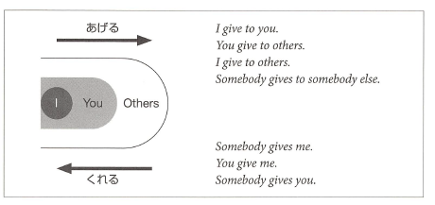

ほしい

- Means (I) want (something).

- Considered an い-adjective and is usually preceded by the particle が. In negative sentences は is also used

- It is similar to たいin that its use is primarily limited to first person.

- To express it applied to second or third person:

  - Quote

    - Ex. ロバートさんはパソコンがほしいと言っています

  - Guess

    - きょうとさんはクラシックのCDがほしくないでしょう

  - Special verb

    - ほしがる. Conjugates as う-verb and usually is in the form ほしがって

いる. The particle after the object is を.

o トムさんは友だちをほしがっています。

Potential Verbs

- They conjugate as る-verbs

- Particles that take particle をcan take either を or が when in potential form. できる takes が almost all the time

Examples: 私は日本語を話せる |  |  | 漢字が読める
 | 私は泳げないんです |  | 山に登れる
 | 仕事ができる
Verb |  | Present
る | ＋られる | 見られる
う | ＋える | 読める
くる |  | こられる
する |  | できる
 | ら-less
 | potential
 | form
出る | 出れる
くる | これる

～かもしれません
- May not

- Short form: かもしれない or simply かも

- Means that something is a possibility; when you’re not really sure but are making a guess

- It goes after the short form of predicates

- It goes directly after the noun or な-adjective in present tense affirmative sentences (no だ)

ほうし (I want something)

～かもしれません (it is a possibility)

あげる/くれる/もらう (giving)

～たらどうですか (advice or recommendation)

Number + も/Number + しか + Negative

Lesson 15
Intention/plan/intend to do:
Volitional Form

- Less formal equivalent of ましょう

- Use it with か to ask for an opinion in offer or suggestion (Shall)

Volitional Form + と思っています

- Talk about determinations. “I’ve decided to/ I’m going to”

- と思います suggests decision was made on the spot

- と思っています suggests you have already decided to do something

- Using present tense= talking about prediction. Using volitional= talking about intention

～ておく/ In advance

- Describes an action done in preparation for something

- Short form + て. Often shortened to とく in speech

- Ex. あした試験があるので、今晩勉強しておきます

Volitional Form (suggest plan to close friend)

Volitional Form + とおもっています (talk about resolution)

～ておく (action performed in preparation of something)

Using Sentences to Qualify Nouns

Lesson 16

～てあげる/てくれる/てもらう (helping verbs, giving or receiving of services)

～ていただけませんか (Make a request, different degrees of politeness)

～といい (Hope something nice happens)

～時(とき): (While/When something happens / Describe when something happens or happened)
Short form + とき

～てすみませんでした (Describe things you have done that you want to apologize for)

Lesson 17
Phrases:
かな~ I wonder

1: ～そうです (I hear) – I have heard that this thing is….
- Add to end of short form sentence

2: ～って – quote what you have heard

3: ～たら - B is valid only if A is fulfilled
- A たら B
- だったら
- The initialたinたらcomes from the short form past tense endings of predicates (main verb)
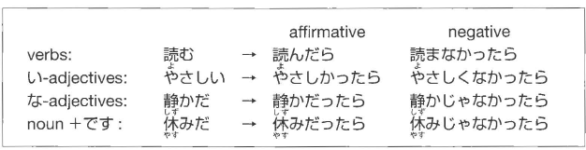

4: ～なくてもいいです – do not need to do
- Negative short form, drop final い
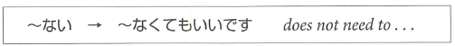

5: ~みたいです – resembles someone / looks like someone / acts like / it seems that

6: ～前（まえ）に／～てから – event before something happens
- Present short form
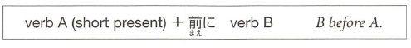
- After event happens: te-form + から
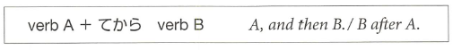

Lesson 18

1 - Transitivity Pairs
Humans act on things / changes that people or things undergo:
Transitive (activities): Subject (agent) + object (thing worked on)
Intransitive (changes): only subject (thing goes through change)

2 ～てしまう
Te-fom + しまう
1: “one carries out with determination”
2: “lack of premeditation or control over how things turn out” (sense of regret/not intend to do)
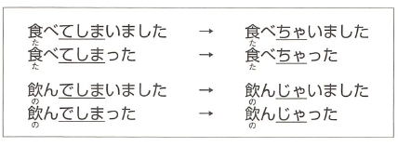

3 ～と
Present tense form of a predicate + と: situation described by the predicate holds
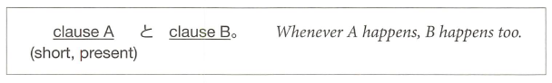
- cause とeffect.

4 ～ながら
Connect 2 verbs to say 2 actions performed at the same time
- word stem + ながら (2nd verb {verb after ながら} can be in any form)
- verbstem 1 (u sound -> i sound) + ながらverb 2

5 ～ばよかったです
I wish I had done / I should have done something
- describe alternate course of action/regret
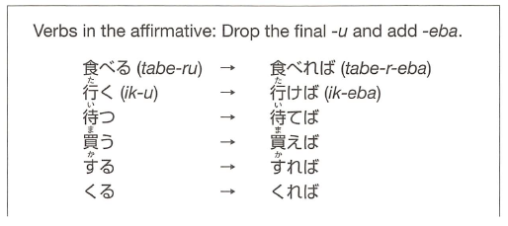
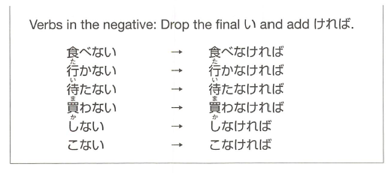

Lesson 19

Honorific Verbs / Graciously
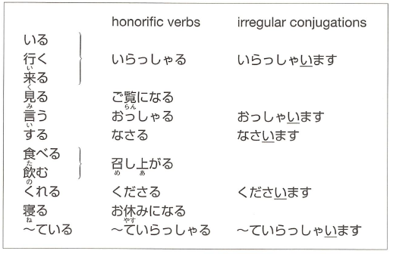
Honorific verbs are not available:
- ていらっしゃいます instead of ています(if the sentence has the helping verb ている)

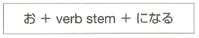

- Keep conjugation form example:
社長はたばこを吸います -> 社長はたばこをお吸いになります
おすいになります
- Not すうbut すい (verb stem, conjugated to ‘ee’ sound) as conjugated in the original
- した might become った
  - If it appears that end of a sentence (or with a ‘but’ ~ が’) is した
  - する (なさる) is always なさった

Giving Respectful Advice
お + verb stem + ください
- するuse ご instead of お

Special honorific verb examples:
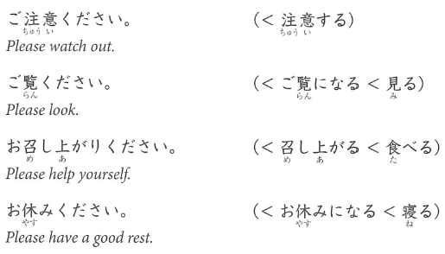

3 ～てくれてありがとう
- Express gratitude to someone
- Refer to specific action that you are grateful for
Te form + くれてありがとう

- When honorific is needed (you are not close or social hierarchy)
  - Te-form + くださってありがとうございました

4 ～てよかったです
Xがあります/ います – there is
- Te-form + よかった: “I’m glad that such and such is/was the case”
  - Negative：te-form なくて
  - Negative te-form reminder: only use the なくて…
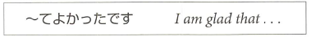

“thank you for being such-and-such a person”
- Use でいる instead of です
For giving a reason
- Use the because part (usually second in English) as the first part with dictionary form then the first part afterwards

5～はずです
- Sentence ending in short form + はずです: Something is “supposed to be the case”
- What you believe is true/is the case, lack conclusive evidence
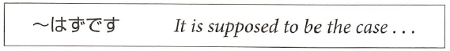
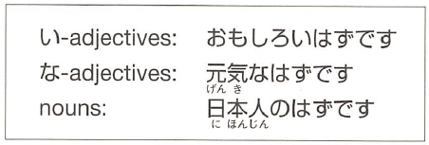
- If present keep する as する and not した
- With potential form keep in ...る form and don’t conjugate

Past tense:
- Something that was supposed to be the case but turned out to be otherwise
- Present tense + はずでした

Negative:
- Negative verb + …たはずです

Something is inconceivable:
- はずがありません and はずがない
- “I cannot imagine”

だったん - was

Lesson 20

1. extra modest expressions
https://sethclydesdale.github.io/genki-study-resources/lessons/lesson-20/grammar-1/
- Talk modestly of our own actions
- Verbs usually in long form
- Ends sentence with ‘sir’ or ‘ma’am’
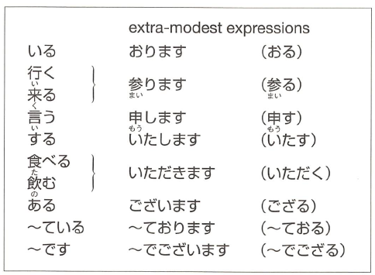
Used to lower your status and elevate the listeners status.

From sentences:
V:
今年 [ことし] - this year

N:
卒業 [そつぎょう] – graduation
文化 [ぶんか] – culture
興味 [きょうみ] – interested in something
階 [かい] – story / floor

Phrase:
一年間 [いちねんかん] – period of one year
来年 [らいねん]- next year

examples:

私は来年も日本に おります。 (います => おります)
(I will be in japan next year too)

私は今年の六月に大学を卒業いたしました。
I graduated from college this June, sir/ma’am.

お手洗いは二階 でごいざいます。 (です => でございます)
(The bathroom is on the second floor)

2. humble expressions

To lower your own status and raise the subject in your sentence's status

general form:
お + (verb masu stem) + する。

for ~する verbs, usually ご instead of お

example:

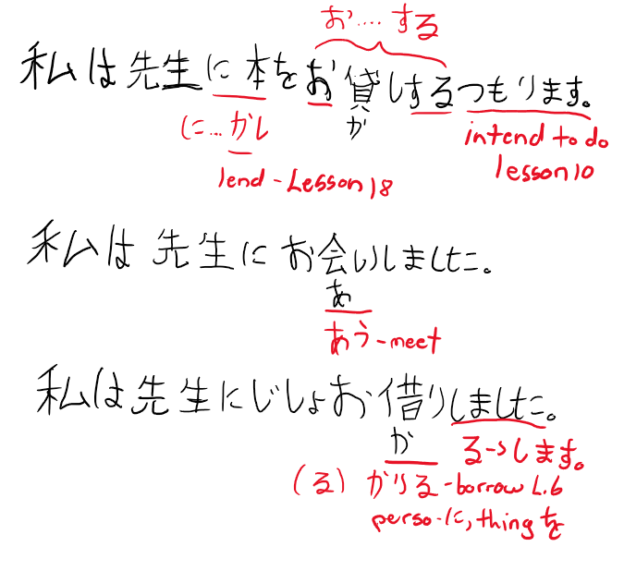
Lend – lesson 18, intend – lesson 10

する compound verbs, only have ご or お
お/ご + noun + する

for もらう (to receive – L.14), => いただきます

for あげる (to give – L.14), => さしあげる

with verb (humbly did an action) て- form+いただきます (did for me)

うかがう – humbly visit and ask questions

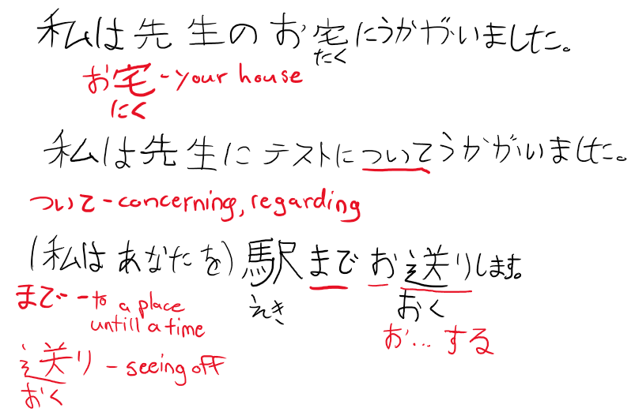

example:
私は先生に花を さしあげます。
(I will give my professor flowers)

use the verb うかがう to be humble in both visiting and asking questions.

example:
私は先生のお宅に うかがいました。
(I visited my professors house)

私は先生にテストついて うかがいました。
(i asked my professor about the exam)

note that the extra modest form raises the listeners status, whereas humble form raises the subjects status (for example the sensei u are referring to in ur sentence)

3. without doing X

verb + ないで = without doing X

Missed action as ~ない (short negative present) + で
Present form of ~ない for present and past
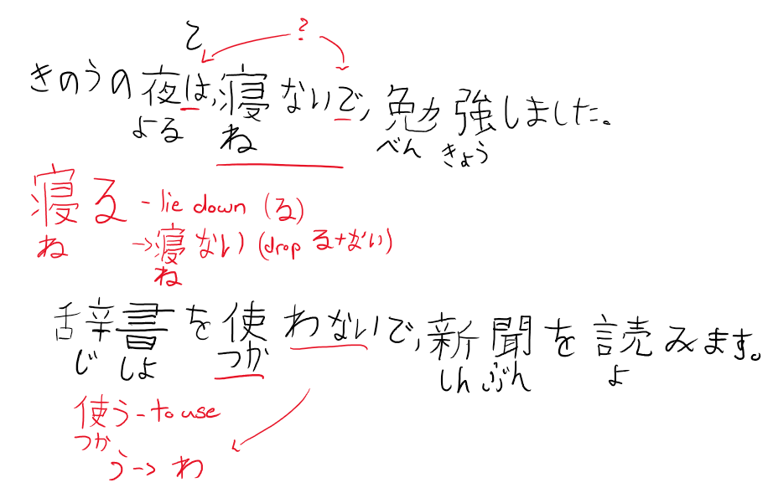

example:
昨日の夜は、寝ないで、勉強しました。
(last night, i studied without any sleep)

4. questions within larger sentences

you can include questions within larger sentences.

- Quoted questions in short form
- Clause ends with か when it contains だれ or なに
- Clause ends with かどうか when it does not contain a question word
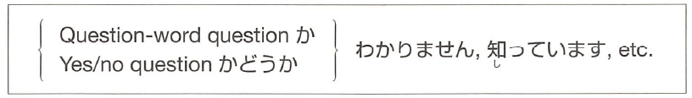
か:
Do you know if…./can/is (currently in the process of..)/where/what…
かどうあ:
Do you know if…. Likes/good at/…
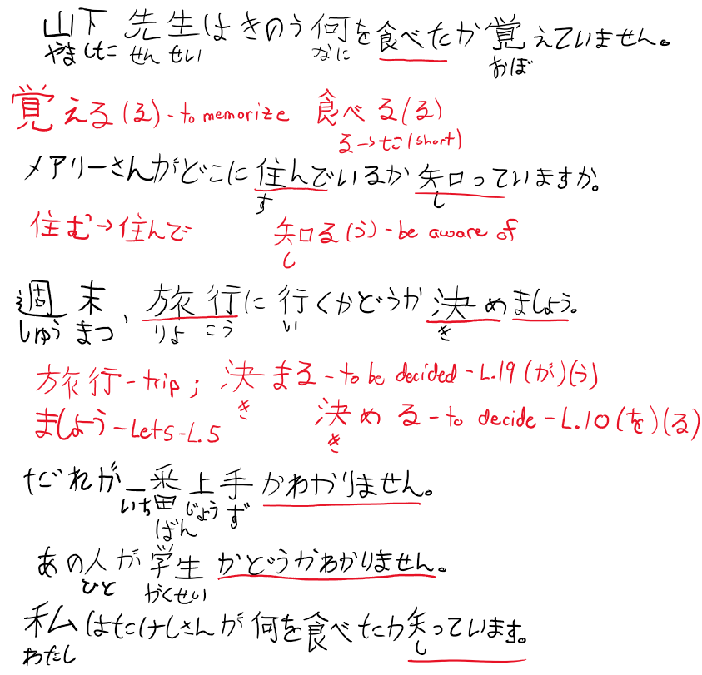

5. the name of objects.

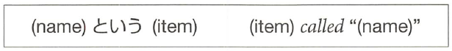
example:
ポチという犬。 (the dog called "pochi")
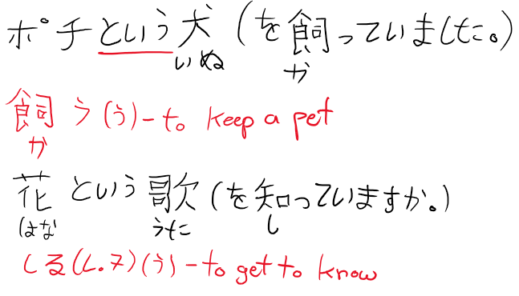

6. easy/hard to do

(verb masu stem) + やすい/にくい = (verb) is easy/hard to do.

- Easy: verb stem + やすい conjugate like い-adjective
- Hard: verb stem + い-adjective form of にくい
- Place something is easy/hard to do in
- Tool easy/hard to do something with

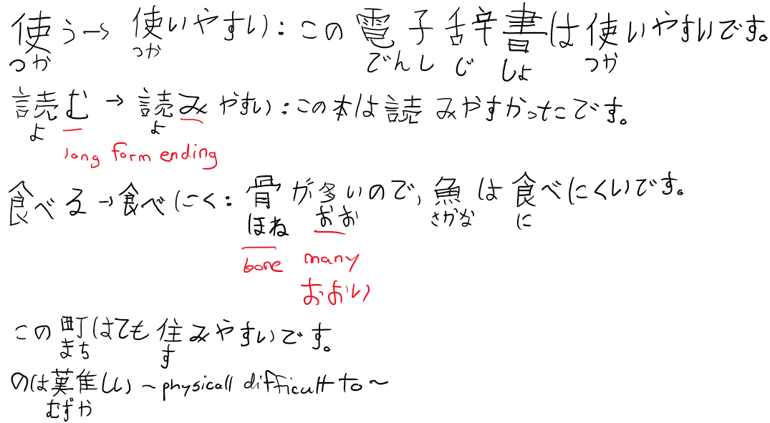

examples:
この電子辞書は使い やすいです。
(this electronic dictionary is easy to use)

骨が多いので、魚は食べ にくいです。
(because there are many bones, fish are hard to eat)

この町はとても 住みやすいです。
(this town is very easy to live in)

note that it refers to the psychological state of whether it is easy/hard to do

example:
この雑誌は 買いにくい。
(this magazine is hard to buy. (because im embarrassed by its contents))

vs

この雑誌を 買うのは難しい。
(this magazine is hard to buy. (because it is rare and hard to find in circulation)

Lesson 21

1. Passive sentences / inconvenienced by something / bothered by

Passive sentence:
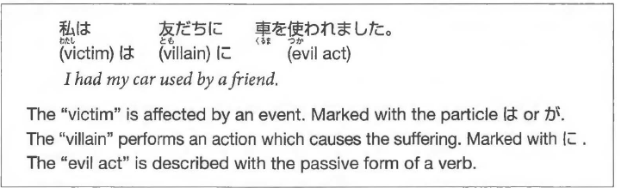
general form:
X は Y に (verb passive form)
= X had (verb) done to him by Y.

Passive Forms:
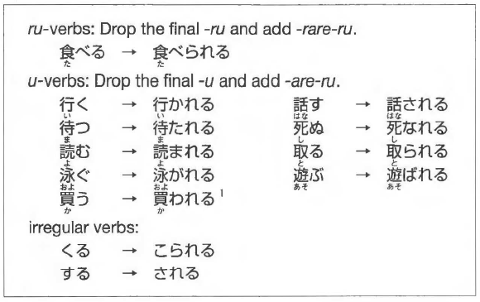
うending becomes ‘w’ (う -> わ) like negative short form
Passive forms ofるand くる are the same as potential form (lesson 13)
Passive formう is different than potential form

Passive forms conjugate as regular る-verbs (including う):
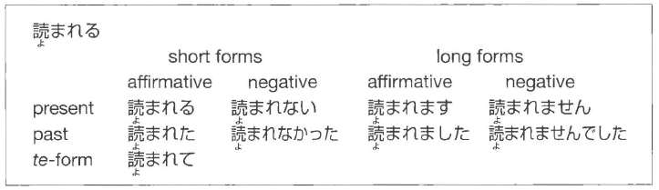
Used for being: angry, embarrassed, sad, and hurt

NOTE: Only used for verbs and not adjectives
  - Situations where something took place due to an action, not that something is described as ‘bad’

Example Sentences:
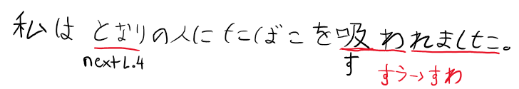
I was annoyed with the person sitting next to me for smoking.

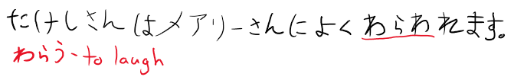
Takeshi is often laughed at by Mary.
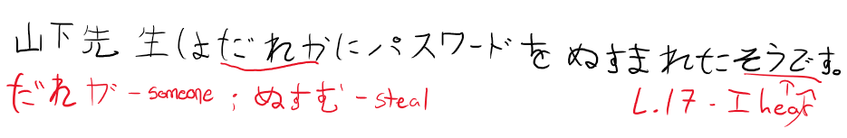
I hear that Professor Yamashita had his password stolen by someone.

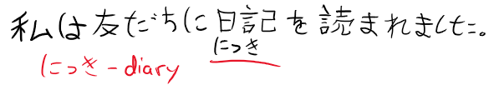
I was annoyed with a friend of mine for reading my diary.

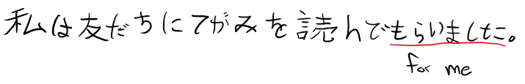
I had a friend of mine read the letter for me.
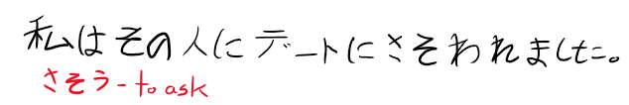
I was asked out by that person for a date.
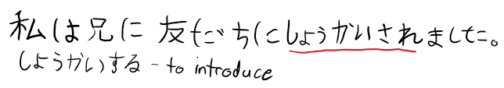I was introduced by my big brother to a friend of his.
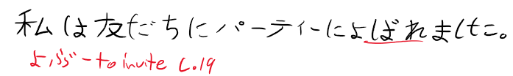I was invited by a friend to a party.
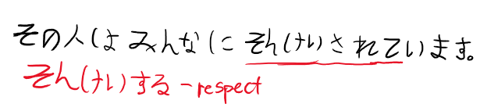
That person is looked up to by most everyone.

Side note:
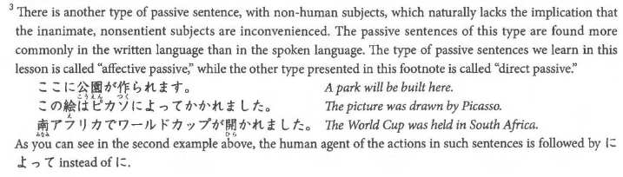

2. てある - situation that has been brought about on purpose (person remains unnamed)

て-form + ある (helping verb)
が – used for most of them instead of は

Sentences:

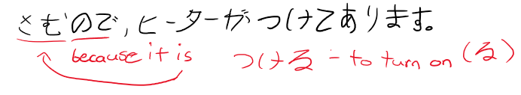
The heater is on, because it is cold.
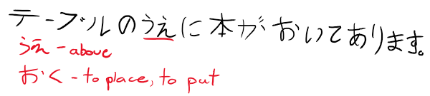
A book is on the table.
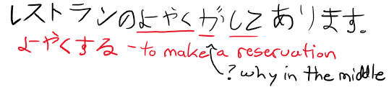
A restaurant reservation has been made.
- It is using reservation not ‘to reserve’ so no する.

its kind of like an intransitive form of ている。

also implies that something has been brought about on purpose by somebody.

example:
窓 が 閉めてあります。
(the window is closed (by somebody, and is still closed till now))
vs
窓 が 閉まっています。
(the window is closed (just a statement that it is closed))

3. ~間に ->（あいだ）に ~ event takes place in middle of another event

A 間に B – event B takes place in the middle of another event A
Event A described with continuous form ている
- verb A is always in the present tense

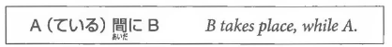
A – can be a noun or verb
B – must be short and can happen within A boundaries
If B happens throughout the time A occurs, then:
間に become 間 (drop the に)

Sentences:
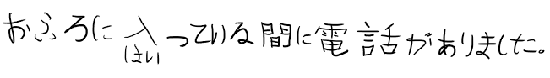There was a phone call while I was taking a bath.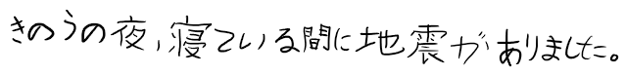 There was an earthquake while I was asleep last night.
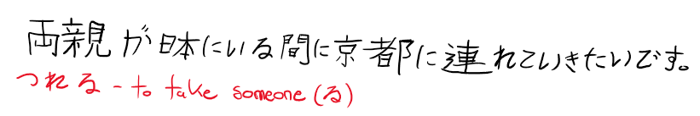
I want to take my parents to Kyoto while they are in Japan.
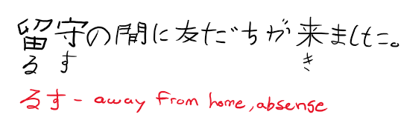
A friend came while I was out.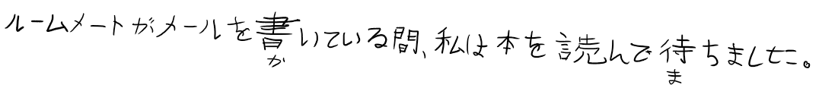 I waited, reading a book, while my roommate was writing an e-mail.

general form:
A (ている
) 間に B.
(in the middle of/while A, B)

example:
お風呂に入っている 間に 電話がありました。
(there was a phone call while i was taking my bath)

A can be a noun:

example:
留守の 間に 友達が来ました。
(while i was absent, my friends came)

for the above, B lasts for a short duration. if B extends throughout the time A occurs, use 間

example:
ルームメートがメールを書いている 間、 私は本を読んで待ちました。
(while my roommate was writing a mail, i waited, reading a book)

4. adjective + する: “to make”
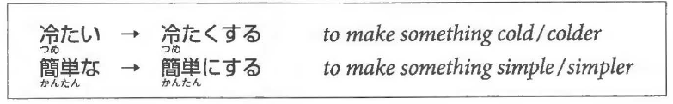
- become good/better at doing X
-い ->く
- な ->に

(adj) + する = to make something (adj)

similar to なる and its conjugations too.

i adj:
冷たい => 冷たくする。
(to make something cold/colder)

na adj:
簡単な => 簡単にする。
(to make something simple/simpler)

example:
部屋を きれいにしました。
(i made the room clean)

Sentences:
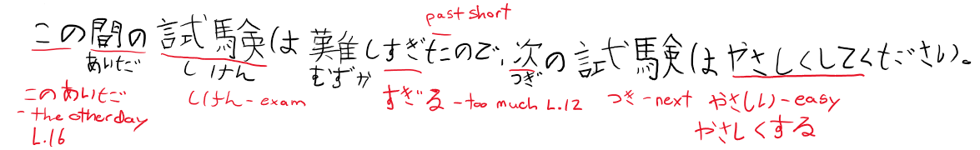
Please make the next exam easier, because the last one was too difficult.

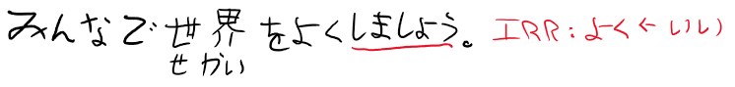
Let's join our forces and make the world a better place.
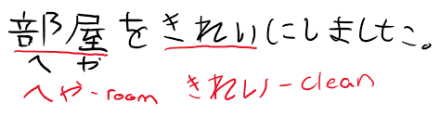
I made the room clean.
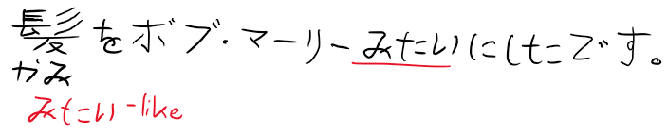
I want to make my hair like Bob Marley's.

5. ～てほしい: “I want him to do...”
- describe your wish

Don’t want someone to do something:
- negate ほしいand say ～てほしくないです
OR
- negate the verb and say ～ないでほしいです．

Sentences:
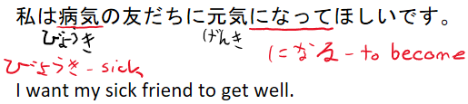

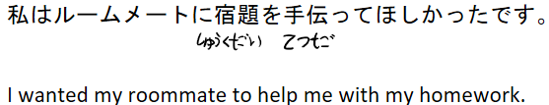

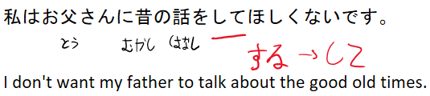

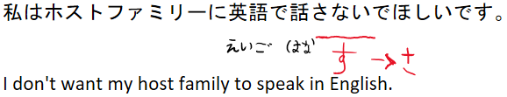

(私は) person に (verb) て欲しい。
= i want person to do (verb)

example:
私 は ルームメート に 宿題を手伝って欲しいです。
(i want my roomate to help me with my homework)

u can say i dont want him to do X by negating the 欲しい to 欲しくない or by making the verb negative + 欲しい。

Lesson 22

Causative sentences
- Who makes/lets someone do something
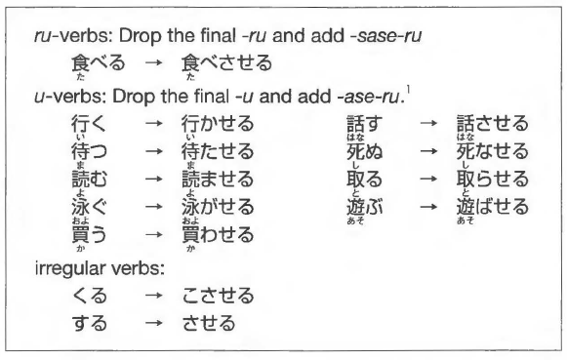
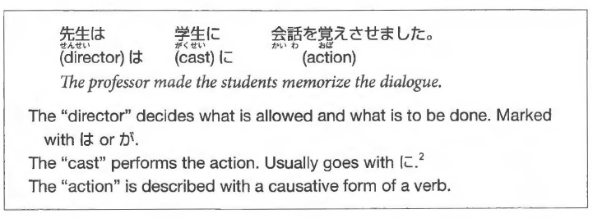
- If helping verb: てあげる・てくれる・てもらう follows causative verb, it is the “let” clause
- causative + てください to ask for permission/volunteer
- Use を instead of に when:
- the action is a reflex: crying and laughing
- if a verb does NOT originally use を
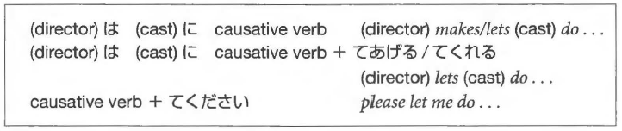

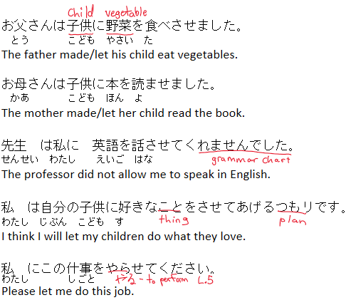

2. verb stem+なさい(command)
なか
(verb masu stem) + なさい = a command to do (verb).
“don’t do…” – verb + のをやめなさい
やめなさい comes from やめる(to stop)

- may sound like u are "talking down" to somebody.
- think you are more mature/know better/should be obeyed
- parents use towards children/teachers use towards students

うちに毎日 電話しなさい。
まいにち でんわ
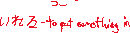
Call home every day.

かっこの中に単語を入れなさい。
なか たんご ぃ
Fill in the blanks with a word.

文句を言うのをやめなさい。
もんく い
Stop complaining.

3. ~ば conditional (if A, then B)
A ば B = If A, then B.
A - condition where B must follow
B - consequence described
A guarantees a good result in B
Used to advise A
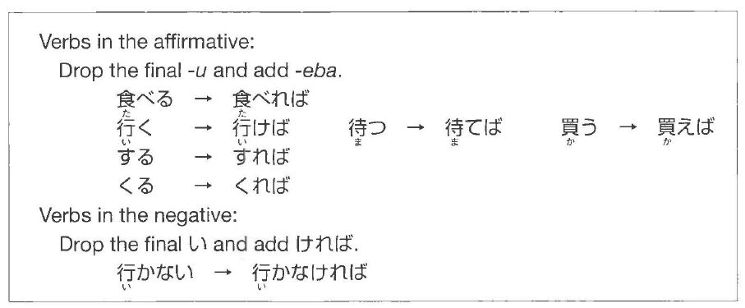

B can contain expression like 大丈夫です orいいんです
だいじょうぶ

車があれば、いろいろな所に行けます。
くるま ところ い
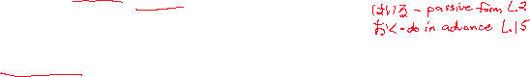
If you have a car, you can go to various places.

かぎをかけておけば、どろぼうに入られません。
はい
If you lock the doors and windows, you won't have your apartment broken into.

大家さんに言わなければ、わかリませんよ。
おおや
If you do not tell the landlord, he will never find that out

走れば、霊車に間に合います。
はし でんしゃ ま あ
If I run, I will be able to catch the train.

この薬を飲めば大丈夫です。
くすI) の だいじょうぶ
You will be okay, if you take this medicine.

先生 に 聞 けばいいんです。
せんせい き
All you have to do is ask the teacher. (If you ask, everything will be fine.)

4. ～のにdespite

(short form A) のに B
= despite the fact that A, B.

both A and B must be facts
- If A ends with な or noun+です it appears (with?) な similar too んです.

example:
この会社はお金がある のに、給料は安いです。
(Although the company is rich, the workers salaries are low)

when A ends in な adj or noun, add a な at the end of A to become なのに.

この会社はお金があるのに 給料 は安いです。
かいしや かね きゅうりよう やす
This company is rich, but its workers salaries are low.


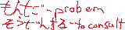
家にいるのに、電話に出ない。
いえ でんわ で
She is home but does not answer the phone.

田中さんは親切なのに、山田さんは田中さんがきらいです。
たなか しんせつ やまだ たなか
Ms. Tanaka is nice, but Ms. Yamada does not like her.

大きい問題なのに、あの人はだれにも相談しません。
おお もんだい ひと そうだん
It is a big issue, but he does not consult with anybody.

5. ～のような／～のように(is like / do something like...)

(noun A) のような (noun B) = A is similar to/like B (in appearance/quality)
- みたい (Lesson 17) used in the same way except の is not used

私 は 鎌倉 のような町が好きです。
わたし かまくら まちす
I like towns like Kamakura.

私 はアウンサン・スーチーのような人になリたいです。
わたし ひと
I want to be a person like Aung San Suu Kyi, the Burmese democracy leader.

メアリーさんは魚のように上手に 泳げます。
さかな じょうず およ
Mary can swim very well, just like a fish.
アントニオさんは孫悟空 のように強いです。
そんごくう つよ
Antonio is strong like Son Goku.

この町は夜の墓場のように静かです。
まち よる はかば しず
This town is as quiet as a graveyard at night.

あの人はマザー・テレサみたいな人です。
ひと ひと
She is a person just like Mother Teresa.

あの人は 壊れたレコードみたいに同じことを言います。
ひと こわ おな い
She says the same thing over and over again, just like a broken vinyl record

Lesson 23

Summary:
1. Causative-passive Sentences
2. Even if.. with ても
3. Decide to do…with ～ことにする
4. Decide your habits… with ことにしている
5. Until…with ～まで
6. Methods with 方（かた）

1. Causative passive sentences (made to do, harassed, talked into doing something you don’t want to do)
Causative (Who makes/lets someone do something)
Passive (inconvenienced by something / bothered by)
- Passive ending – lesson 21

Causative-passive Sentences
- the passive version of causative sentence
- Made to do / harassed / talked into
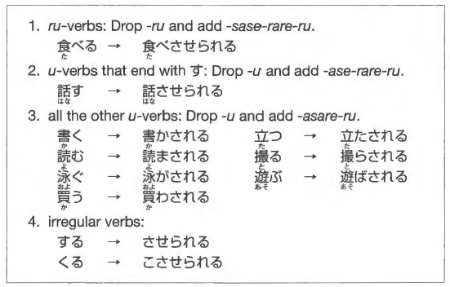

Expected form:
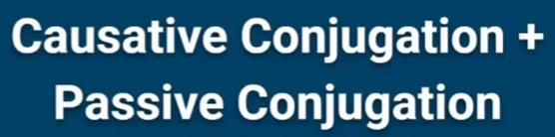

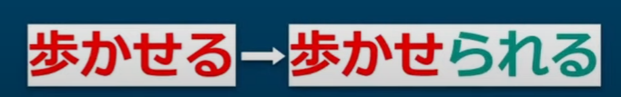
passive ending - lesson 21
- correct but not common

More common:
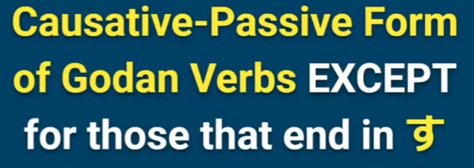

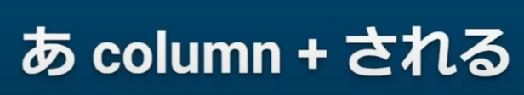

Example:
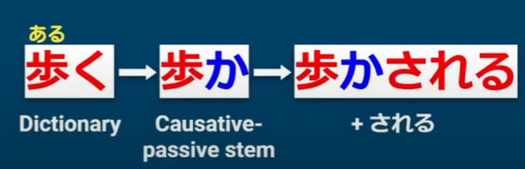

Ru-verbs:

same as: causative + passive
たべる-> causative たべさせる
たべさせる -> drop るadd passive (られる)
たべさせられる

Sentence structure:
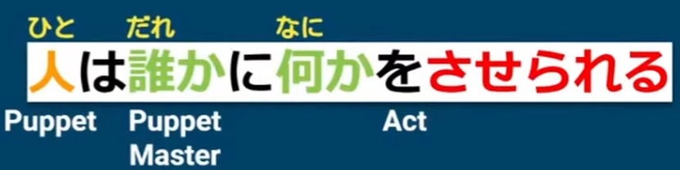

2. Even if.. with ても

A ても、B = even if A, B

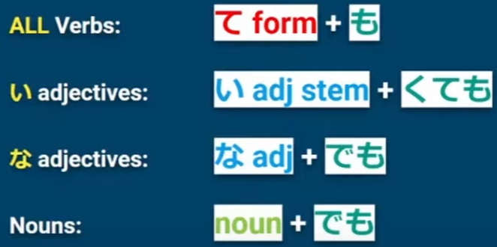
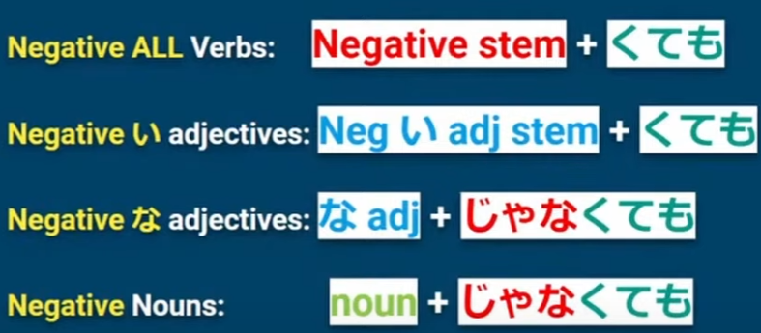
Form in Lesson 6.
いいよ
Lesson 23.
ても
(い-adj: ending い -> く)

3. Decide to do…with ～ことにする

(verb short form present tense) + ことにする = decide to do (verb)
everything before the こと is turned into a noun

example:
車を買うことにしました。
(we have decided to buy a car)

sometimes volitional form is used eg. 行くことにしましょう。
Also means lets do (verb), but has implication that u gave some deliberation.

(verb) + ことにしている
= do (verb) as a regular practice.

example:
絶対にお酒を 飲まないことにしています。
(i have made this firm decision not to drink alcohol and have strictly followed it)

4. Until…with ～まで

A まで、B = until A, continue B.

example:
晴れる まで、喫茶店で待ちます。
(until the sky is clear, i will wait in the coffee shop)

5. Methods with 方（かた）

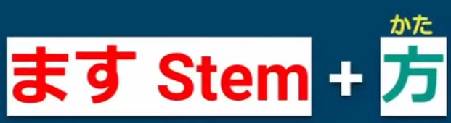
(verb masu stem) + 方 = the way of doing (verb)

example:
考え方 (the way people think)

nouns that come before the verb the を particle changes to の.

example:
漢字を読む => 漢字の読方 (the way of reading kanji)

for ~する verbs, becomes ~のし方.

example:
日本語を勉強する => 日本語の勉強のし方。
(the way of studying japanese)

Misc.

Days of the week:
Sunday | Monday | Tuesday | Wednesday | Thursday | Friday | Saturday
日曜日 | 月曜日 | 火曜日 | 水曜日 | 木曜日 | 金曜日 | 土曜日
にちようび | げつようび | かようび | すいようび | もくようび | きんようび | どようび

Months:
Month | Japanese | Characters
January | ichi-gatsu | 一月
February | ni-gatsu | 二月
March | san-gatsu | 三月
April | shi-gatsu | 四月
May | go-gatsu | 五月
June | roku-gatsu | 六月
July | shichi-gatsu | 七月
August | hachi-gatsu | 八月
September | ku-gatsu | 九月
October | juu-gatsu | 十月
November | juuichi-gatsu | 十一月
December | juuni-gatsu | 十二月

End of sentence:
し – List, Chapter 13
(to become) なる・なりません・なります

Useful phrases:
When we do ‘an activity’…
‘When we play tennis’
テニスをするとき (https://sethclydesdale.github.io/genki-study-resources/lessons/lesson-22/workbook-3/ - Q5)

Particles:
- まで is used to talk about the journey instead of using に which talks about the destination.

